## Problem



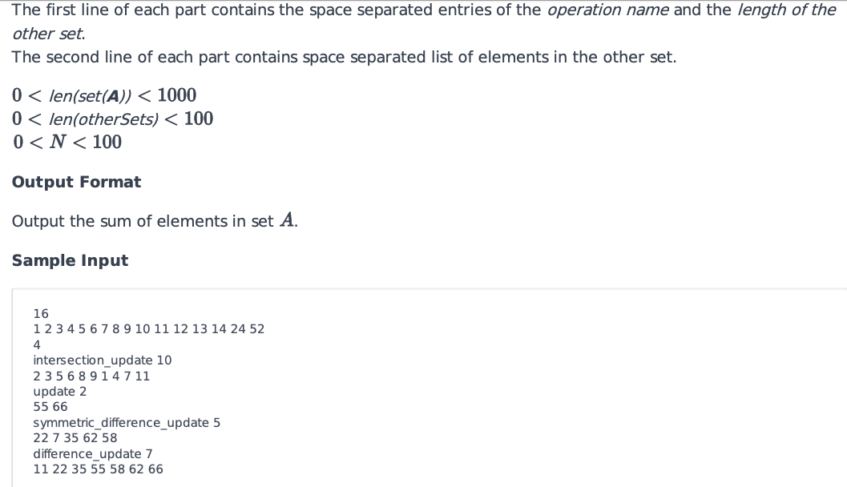

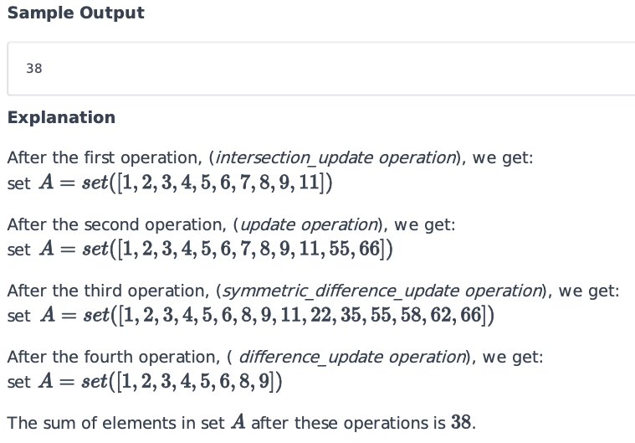

## Solution

# Enter your code here. Read input from STDIN. Print output to STDOUT

_ = int(input())

s1 = set(map(int, input().split()))

N = int(input())

for _ in range(N):

    cmd, _ = input().split()

    s2 = set(map(int, input().split()))

    if(cmd == "intersection_update"):

        s1.intersection_update(s2)

    elif(cmd == "update"):

        s1.update(s2)

    elif(cmd == "symmetric_difference_update"):

        s1.symmetric_difference_update(s2)

    elif(cmd == "difference_update"):

        s1.difference_update(s2)

print(sum(s1))